**Wireframe**

**Index.html**

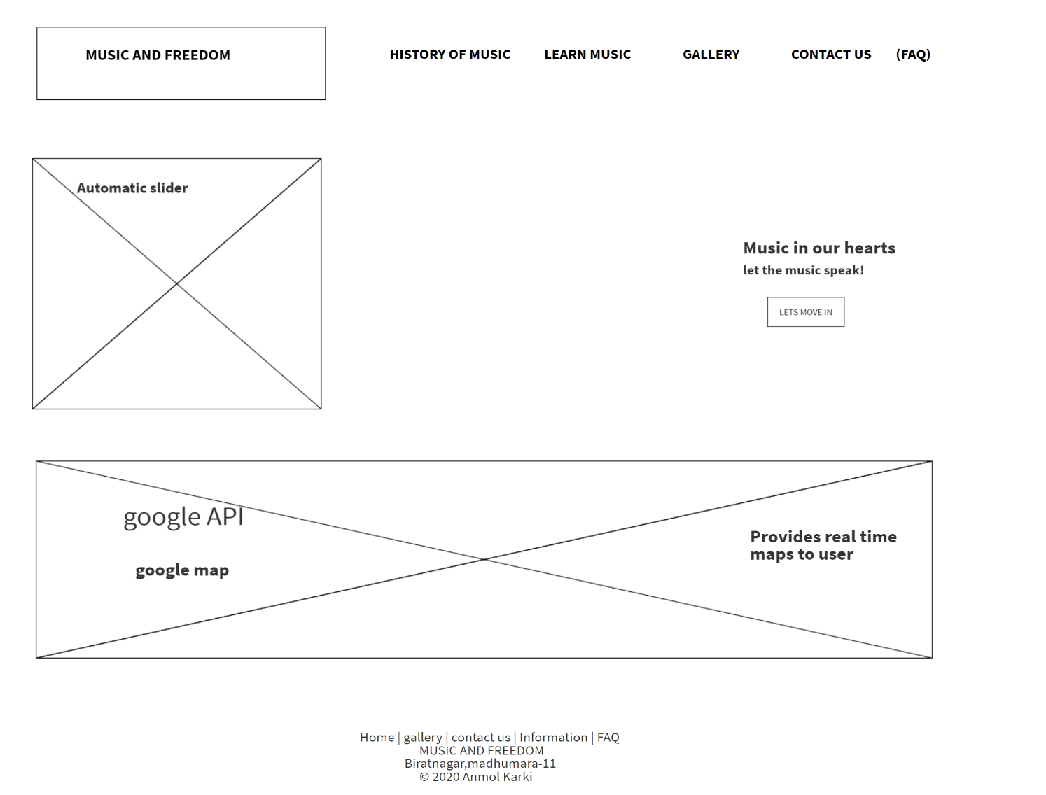

**Contact.html**

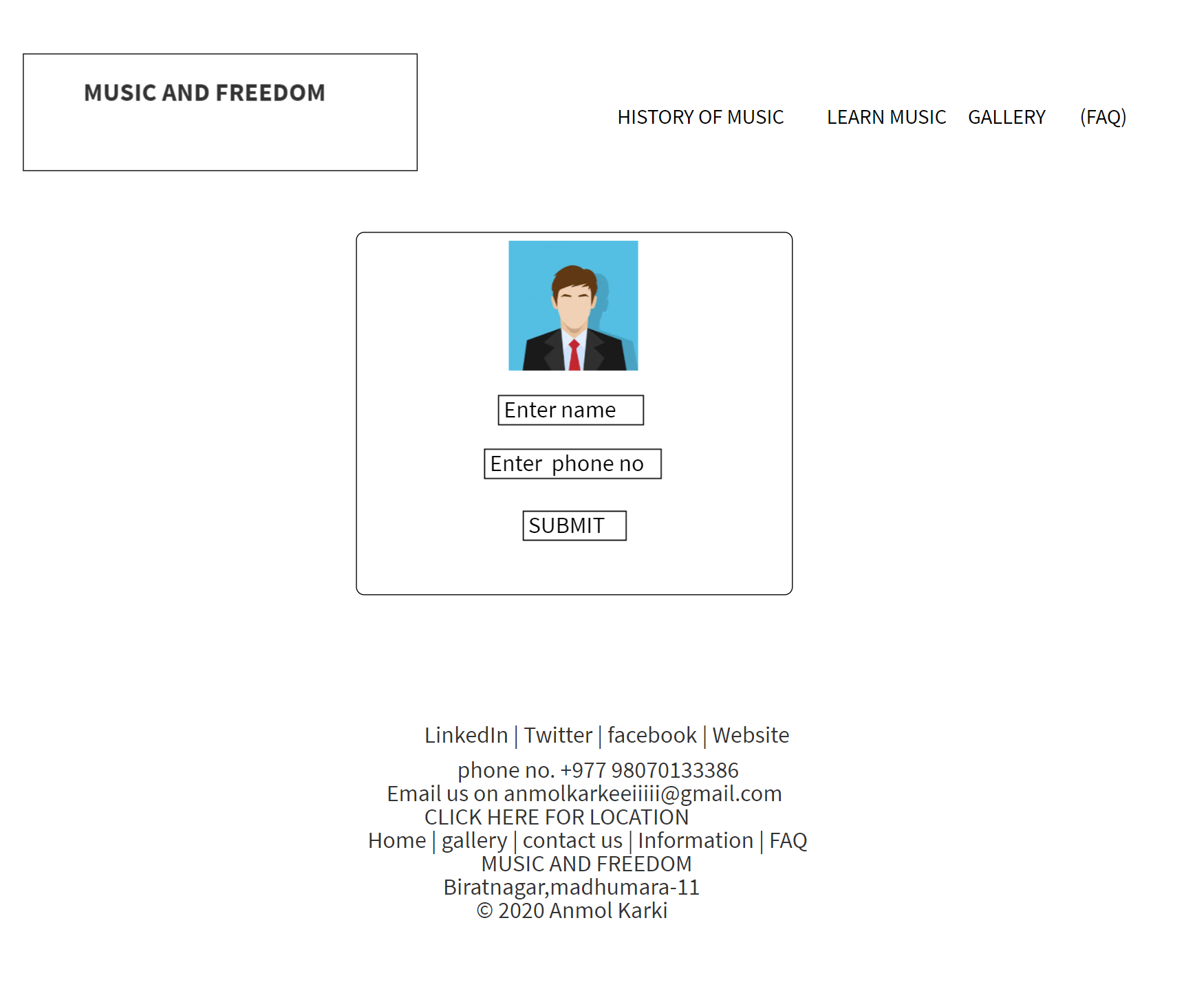

**Gallery.html**

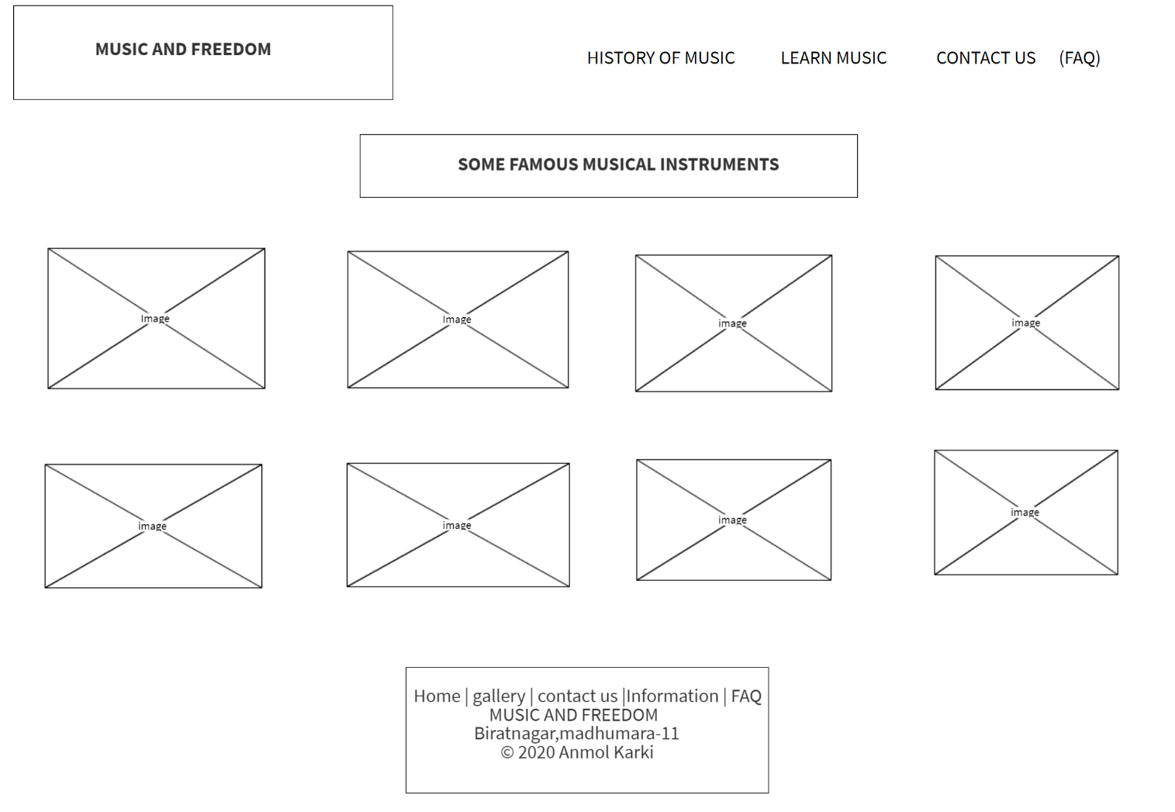

**Table.html**

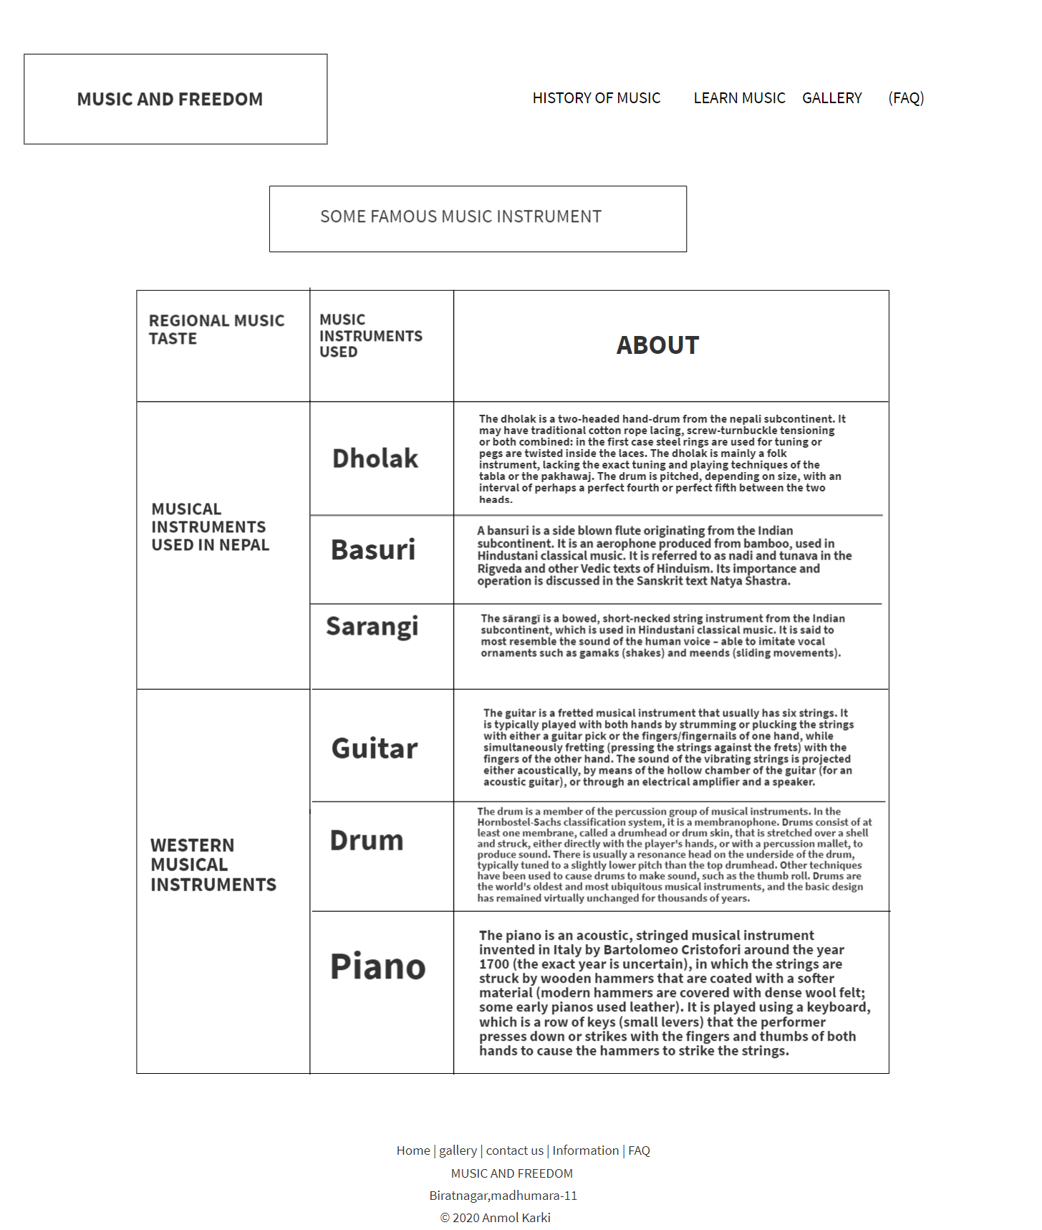

**Faq.html**

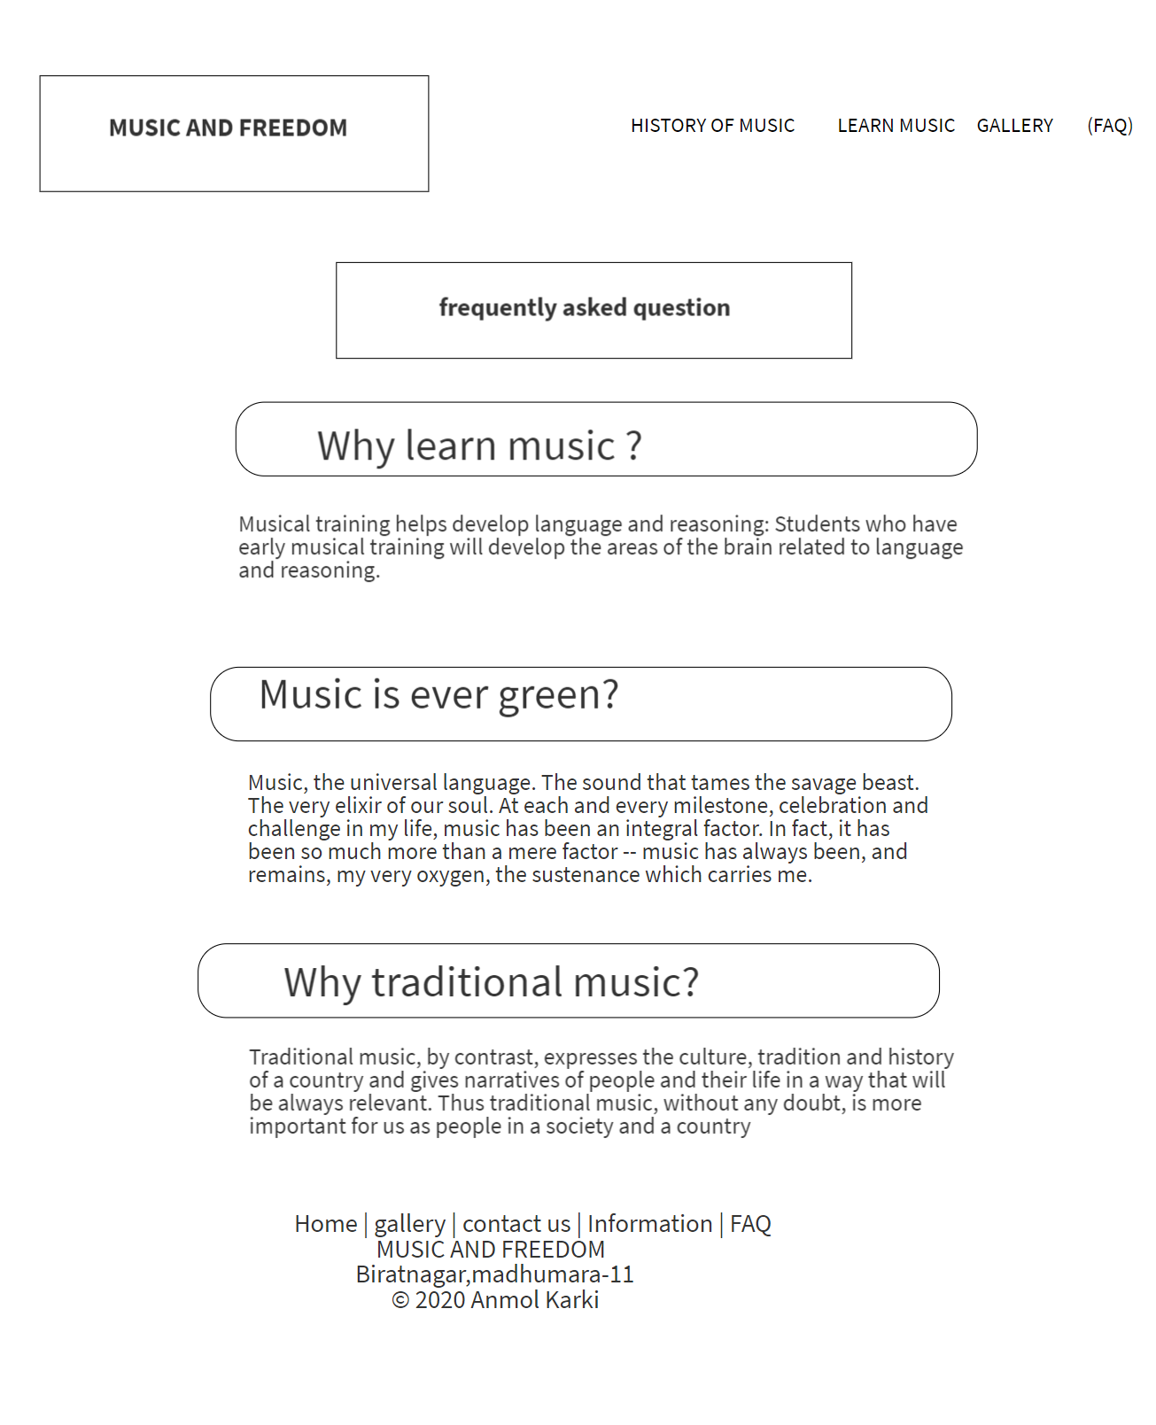

**Site map**

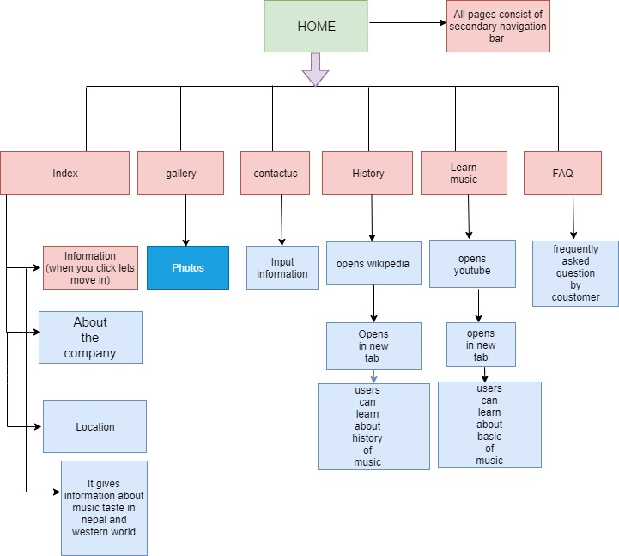

**DESCRIPTION**

This webpage is developed to educate people in music sector. It consists of 5 web pages such as index.html, gallery.html, contact.html, faq.html, table.html.

Index.html provides the overall idea to viewer what this is web pages are meant for. User can navigate every webpage through index.html. It consists of footer through which you can also navigate through webpages. JavaScript is used to slide show the image for immersive experience to user. It also indicates about the location of our office.

Gallery.html consist of several picture. There is some great music instrument presented. You can navigate through every page and also consists of footer. User can also navigate through pages from footer.

Contact.html provides user a special facility to put their information to us and we can contact very soon when we received. Java script is used to validate the information of user weather it is real or fake ones. You can navigate through every page and also consists of footer. User can also navigate through pages from footer.

Tables.html is a page which gives users information about the musical instrument used in west and Nepal. You can navigate through every page and also consists of footer. User can also navigate through pages from footer.

Faq.html is very important page which gives answer to the question which are frequently used. You can navigate through every page and also consists of footer. User can also navigate through pages from footer.